E-COMMERCE ORDER MANAGEMENT DATABASE SYSTEM

4. ORDERS & ORDER_DETAILS TABLE DESIGN

1. Orders Table
The Orders table is designed to store and maintain customer order information in the E-Commerce Order Management Database System. Each attribute is assigned a suitable data type and constraint to ensure proper storage and management of order details.
S.No | Field Name | Data Type | Constraint | Description
1 | Order_ID | INT | PRIMARY KEY | Uniquely identifies each order
2 | Customer_ID | INT | FOREIGN KEY, NOT NULL | Connects the order with its customer
3 | Order_Date | DATE | NOT NULL | Stores the date of the order
4 | Total_Amount | DECIMAL(10,2) | NOT NULL, CHECK | Stores the total amount of the order
5 | Order_Status | VARCHAR(20) | NOT NULL, CHECK | Stores the current status of the order

2. Order_Details Table
The Order_Details table is designed to store and maintain the individual product details associated with each customer order. Each attribute is assigned a suitable data type and constraint to ensure proper management of order items.
S.No | Field Name | Data Type | Constraint | Description
1 | Order_Detail_ID | INT | PRIMARY KEY, AUTO_INCREMENT | Uniquely identifies each order detail
2 | Order_ID | INT | FOREIGN KEY, NOT NULL | Connects the details with the corresponding order
3 | Product_ID | INT | FOREIGN KEY, NOT NULL | Connects the order detail with its product
4 | Quantity | INT | NOT NULL, CHECK | Stores the quantity of the product ordered
5 | Price | DECIMAL(10,2) | NOT NULL, CHECK | Stores the price of the product

3. ATTRIBUTE DESCRIPTION
- Order_ID: Unique identifier for each customer order.
- Customer_ID: Connects the order with the corresponding customer.
- Order_Date: Stores the date when the order was placed.
- Total_Amount: Stores the total amount of the order.
- Order_Status: Stores the order status as Pending, Shipped, Delivered, or Cancelled.
- Order_Detail_ID: Unique identifier for each order detail record.
- Order_ID: Connects order details with the corresponding order.
- Product_ID: Connects order details with the corresponding product.
- Quantity: Stores the number of products ordered.
- Price: Stores the price of the product in the order detail.

4. CONSTRAINTS
- PRIMARY KEY: Uniquely identifies records in the Orders and Order_Details tables.
- AUTO_INCREMENT: Automatically generates the Order_Detail_ID.
- NOT NULL: Ensures that required information is provided.
- FOREIGN KEY: Establishes relationships between Customer, Orders, and Product tables.
- CHECK: Ensures that Total_Amount and Price are not negative.
- CHECK: Ensures that Quantity is greater than zero.
- CHECK: Allows only Pending, Shipped, Delivered, or Cancelled as Order_Status.
- ON UPDATE CASCADE: Updates related foreign-key values when referenced IDs are changed.
- ON DELETE CASCADE: Automatically deletes related order details when an order is deleted.
- ON DELETE RESTRICT: Prevents deletion of referenced customers or products.

5. SCREENSHOTS
Figure 1: Orders Table Creation
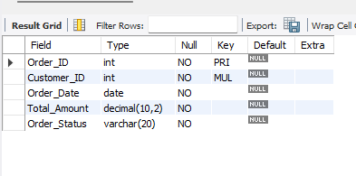

Figure 2: Order_Details Table Creation
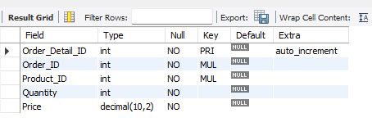
Figure 3: Table Creation Verification
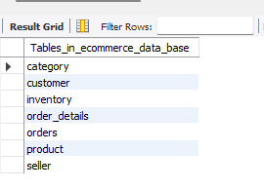

6. CONCLUSION
The Orders and Order_Details tables provide the required structure for storing customer order information and managing the products associated with each order in the E-Commerce Order Management Database System. The defined attributes, data types, relationships, and constraints help maintain accurate, organized, and consistent order data.

